# About the Project

Here I have developed a project on Tour and Travel. Online Tour and Travel Booking is a system that gives you the facility of booking any type of packages. This system is made, so that customer can easily book ticket for all packages of tourist place such as hills, trekking, adventures, spirituals and user can also register for hotels for different types of room.

The project ‘Tours and Travels’ is developed to replace the currently existing system, which helps in keeping records of the customer, details of destination as well as payment received. It saves the precious asset that is time, and also accuracy, reliability and uniformity can be maintained. This project is useful for the manager of the company as it helps them to search the data faster than existing system, to get customer record easily and report of the customer payment, etc are generated as per requirement.

Details of different types of tours which include tours like family tours, couple tours, general tours, date and time of departure and the fair of the tours etc are maintained. Through this site we can provide different types of travel packages to the customers. This sites provide everything related to it itineraries.

This site gives new packages on flexible price, so that user can book easily. According to season admin can change packages. We revise our itineraries regularly. Vacation-O-City offers a large range of travel opportunities. Tours and Travels Project is designed in asp.net programming language, and SQL server used for this site.

In this site, Admin can add packages, add destinations (adventures, spirituals), add hotels details, and delete hotel details. Admin can also add different types of rooms.

## Introduction

Online Tour and Travel is a very user friendly project. In this project user can easily understand and book all packages and also register for hotel. In this project there are various types of forms, like all types of packages, book for package and Room Registration Page in which user can insert his personal needs & facilities then upload his form by which user can register in the web site. In this website user can also pay money through credit card.

This site provides different tour packages, hotel booking and summer special tour packages. Through this site, user can book different types of room such as deluxe room, ac room etc on flexible price.

This site provides different packages, destination, and hotel booking services in one particular state of India. Himachal Pradesh is very popular hill station of north India. Visitors enjoy snow covered mountain peaks and adventure sports like trekking, mountaineering and skiing.

In this website, according to the tour packages it provides services like online booking facilities for all packages and hotels registration to the customer. In this project user can easily understand and fill up the Room Reservation form. User can search for various types of rooms.

Online Tour and Travel is a web based application made in Asp.Net. So with the help of this project user can apply for packages of tour and room reservation.

1

In this project, Admin can add travel packages and all details of hotels which is located in Himachal Pradesh and also add all details of bus for this particular city

## Problem Defination

The purpose of tour and travel is mainly to provide online booking services for the user. This statement describes the problem definition of the proposed system. The purpose of this site is to book online ticket for hotels and all tourist places of Himachal Pradesh.

The problem definition of the vacation-o-city is to book online ticket for hotel and tourist place where user wants to visit. It is a Web Based Application to develop website in which end user interact with the web-app easily. In this website, Customer or User can search and book all tourist places and all hill stations and all hotels of Himachal Pradesh.

The problem is that we although have many websites but they offer a different kinds of services. The customers are enjoying a lot but there is a lack of relationship between travel agency and customers and hence we are establishing that relationship by carrying and servicing all customers in the same manner that we wish to serve.

## ER DIAGRAM

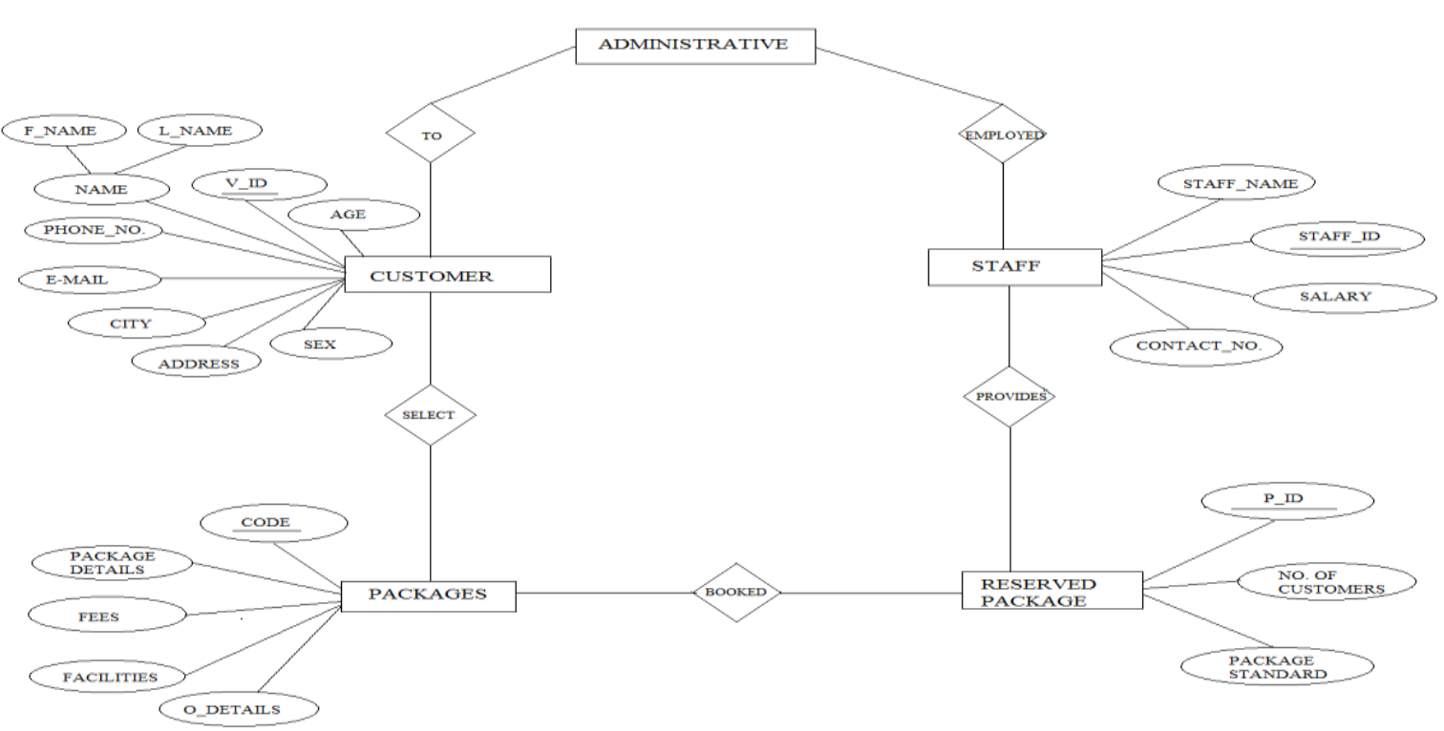

## Data Flow Diagram

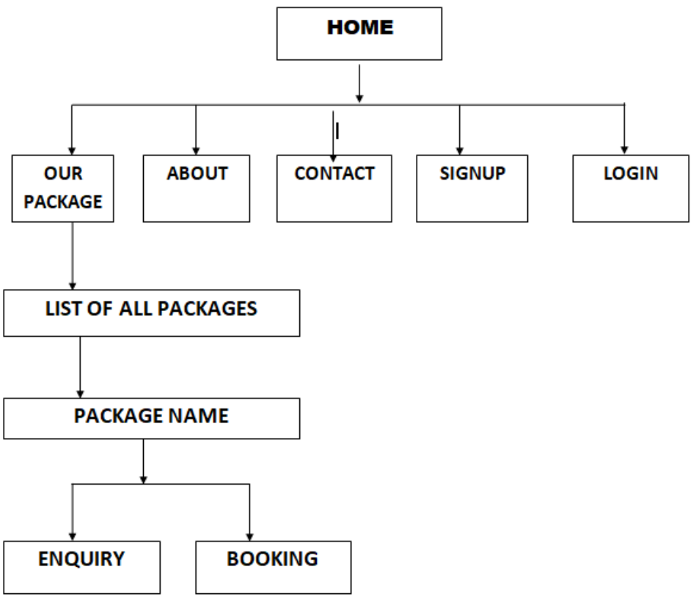

# Problem Statement

* **The purpose of website is established fact that Internet users are increasing today. Today One of the main purposes of the website is to facilitate the offline customer online because customers cannot spend their precious time in markets trying to find out the best deal.**
* **Our priority will be our customers and their travel requirements.**
* **There will be many users visiting the portal and hence we require a strong and reliable frontend which can withhold the users on our site.**
* **We will be putting an effort to provide the right choice to the people when they plan a holiday and beware them from the false advertising.**

## Objective

This system provides Online Registration, Tour Package Information, Bus ticket booking and all other destinations. The purpose of this project is very clear that user can find room facilities easily & hotel service providers also get good customers very easily. Customer can register in the website & can create his own registration then he can receive email for his room status related to his reservation and book all packages. User can register hotel for different types of room what they want.

The Main Goal of this project is to provide a very faster room reservation services and also booking services for different types of packages so any user can get this service very easily.

* Our objective is to make strong relationship with customers so that they can enjoy the holiday of their dreams.
* It saves lots of time , now a days there is a fast process world any one can work quickly so, this project helps that people who are searching for reservation in organization, so they can easily fill up the form and search rooms and different tourist place.
* Possess complete back up services

## Modules Of Project

### Customer

* REGISTRATION
* VIEW PACKAGES
* BOOKING
* GIVE E-PAYMENT
* BOOKING CANCELLATION
* GIVE FEEDBACK

### Admin

* REGISTRATION (LOGIN)
* MANAGING USER
* MANAGE TOUR PACKAGES
* MANAGE TICKET BOOKING
* MANAGE E-PAYMENT
* VIEW CANCELLATION
* VIEW FEEDBACK

## Design

Website Tour and Travel is used to book online ticket for different packages and hotels, adventures and different destinations of Himachal Pradesh. The main page of this website has Home page which contains Register for new account, Login for account.

The user can choose different packages, destinations and hotels from gallery. The user also has the option of changing the password for security purpose and new user must have to create the account to book the packages and hotels. The first option in the navigation drawer is Home, Packages, Hotel, and Destinations (Adventures, Spirituals). Online payment option is also available on this website.

## Working of Website

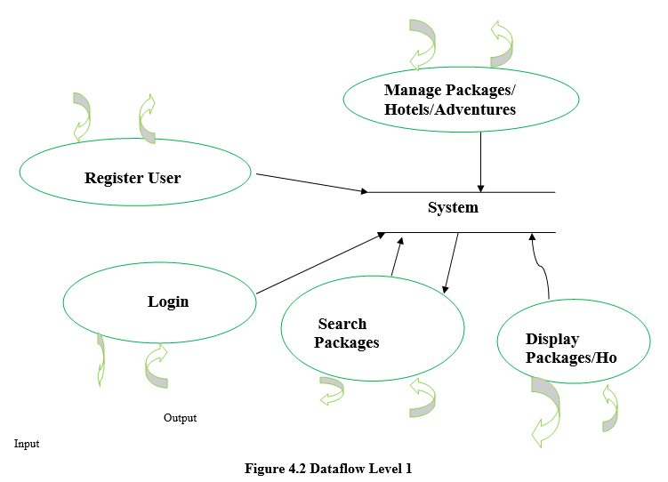

Home Page:

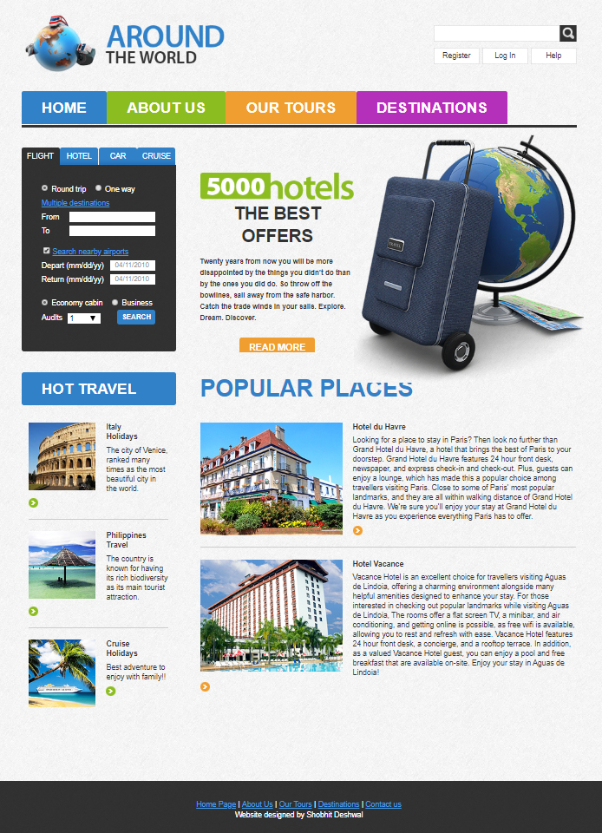



## About Us Page:

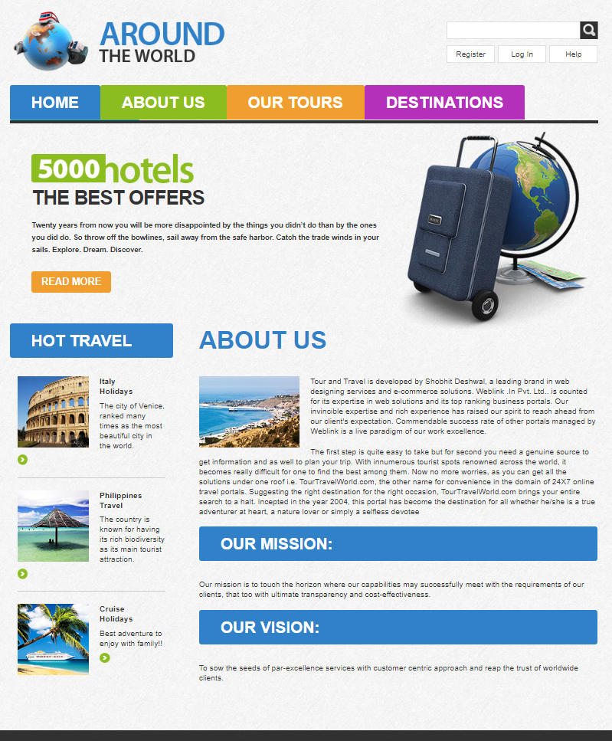

## Tours Page:

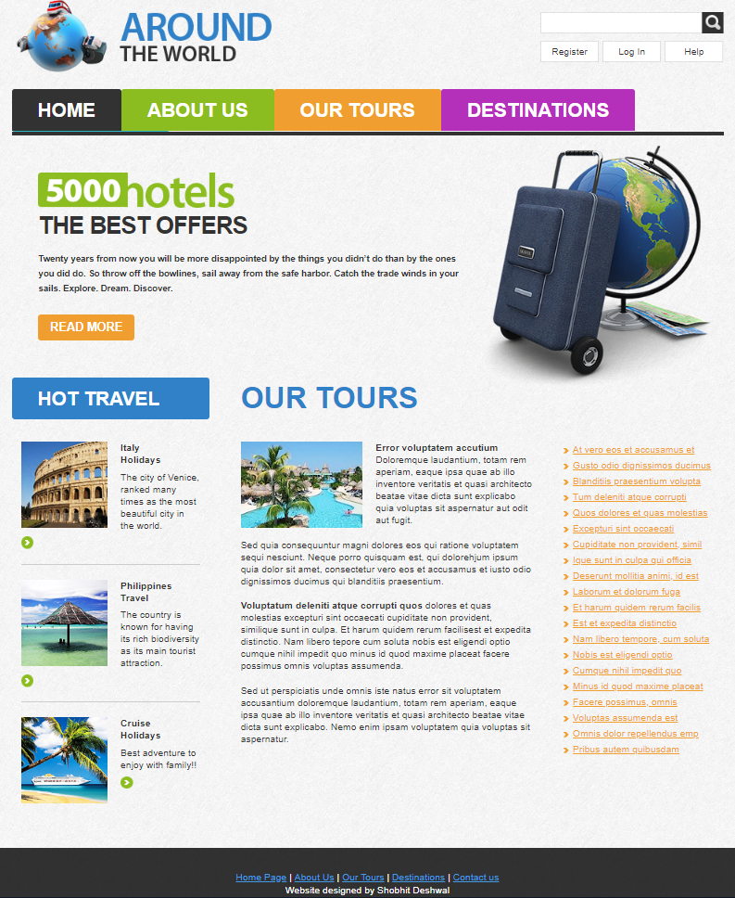



## Destination Page:

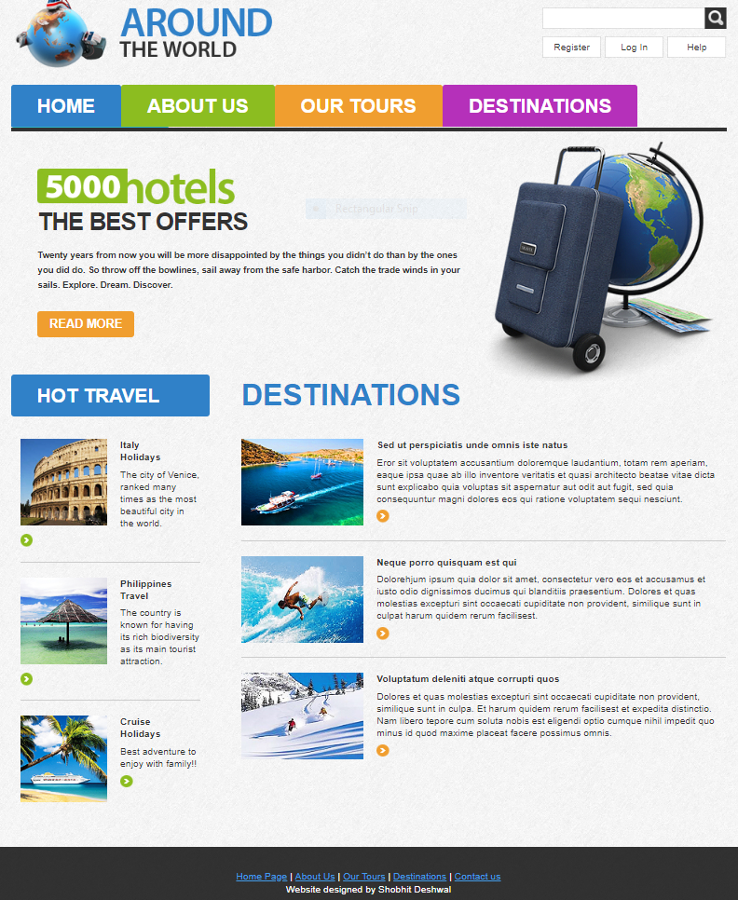



## Contact Page:

